

COMSATS UNIVERSITY ISLAMABAD ABBOTTABAD CAMPUS
Project Report
ShelfWare
“A Store Management System”
BS Computer Science Program
Class:
BCS 3B
Subject:
Database Systems
Submitted to:
Sir Wajahat Ghaffar Mir
Submitted by:
Izza Malik
Malaika Syed
Muhammad Ahmed Hassan
Muhammad Ali
Registration No.:
SP24-BCS-055
SP24-BCS-067
SP24-BCS-077
SP24-BCS-078

Acknowledgement
We would like to extend our deepest gratitude to our respected instructor, Sir Wajahat Ghaffar Mir, for his unwavering support, expert guidance, and constant encouragement throughout the development of this project. His insightful feedback and timely suggestions at every stage were instrumental in helping us understand not only the technical aspects of building a database-driven application but also the importance of planning, problem-solving, and professional discipline. His dedication to teaching and mentoring provided us with the clarity and motivation we needed to successfully complete this project.
We are especially thankful for the time he took to review our work, answer our queries, and provide constructive criticism that enabled us to refine and improve our approach. Under his supervision, we were able to enhance our understanding of real-world software development processes and gain confidence in applying classroom knowledge to practical scenarios. It has been a great learning experience working under his guidance, and we are truly grateful for the opportunity to benefit from his expertise and mentorship.
Finally, we are immensely grateful to each other as a team. This project was a collaborative effort, and its successful completion is a testament to our collective hard work, dedication, and mutual support.
Thank you, Mr. Mir.

Abstract
This document provides an in-depth exploration of the design, development, and deployment of a desktop-based Store Management System, tailored to address the operational needs of small to medium-sized retail enterprises. Developed using Java for the application layer and MySQL for the database backend, the system offers a comprehensive solution for managing inventory, customer data, sales transactions, and billing. The application features a multi-tiered architecture comprising a graphical user interface (GUI) built with Java Swing, a business logic layer encapsulating system rules, and a data access layer employing JDBC for secure and efficient communication with the relational database. Key functionalities include secure role-based authentication, CRUD operations for product and customer management, real-time inventory updates, and automated PDF invoice generation using the iTextPDF library. Designed with a focus on data integrity, usability, and modularity, the system ensures transactional consistency through robust validation mechanisms and structured error handling. This project not only demonstrates the practical application of core database and programming concepts but also highlights best practices in software design, system integration, and user-centric functionality.

Significance of the Name for Our Store Management System

Root Terms:
We chose the term “Shelfware” as it is a creative combination of two words:
- Shelf: Refers to the physical storage areas in a store where products are kept, displayed, and managed. It represents the real-world retail environment.
- Ware: A flexible word with layered meanings:
From software, indicating that the system is a digital application.
From hardware, since the system also works alongside physical tools like shelves, printers, and possibly barcode scanners.
Also, “wares” in English means goods or products for sale a direct link to inventory.
So, Shelfware is a smart, symbolic name that captures both the physical and digital dimensions of your system managing the store shelves through software.

Significance:
We chose the name “Shelfware” because it represents the heart of what our system does:
- It manages real-world store shelves using smart digital tools.
- It bridges hardware (shelves, inventory) and software (GUI, database, billing).
- It’s unique, modern, and easy to remember.
- It reflects the system’s goal: to organize, track, and streamline everything that happens on the shelf and beyond.
- It also gives our project a brand identity, making it stand out as a professional tool — not just a classroom assignment.

Table of Contents
1. Introduction 9
1.1. Project Overview 9
1.2. Purpose and Motivation 9
2. Scope and Objectives 9
2.1. Enable Full Inventory Control 9
2.2. Secure Role-Based Access 9
2.3. Efficient Product Management 10
2.4. Customer Account Management 10
2.5. Interactive Shopping Interface 10
2.6. Simulated Payment Workflow 10
2.7. Automated PDF Receipt Generation 10
2.8. Data Consistency and Transactional Integrity 10
3. System Requirements 10
3.1. Hardware Requirements 10
3.2. Software Requirements 10
3.3. Tools and Technology 11
4. Architectural Design 11
4.1. Presentation Layer (GUI): 11
4.2. Business Logic Layer: 11
4.3. Data Access Layer (DAL): 11
5. Database Design and Implementation 12
5.1. Entity-Relation Diagram: 12
5.2. Database Schema and Tables 13
5.2.1. admins 13
5.2.2. customers 13
5.2.3. customer_accounts 13
5.2.4. products 13
5.2.5. orders 14
5.2.6. order_items 14
5.3. SQL Code 14
6. Business Rules and Data Integrity 18
6.1. Category 1: Data Integrity & Format Rules 18
6.1.1. Valid Email, Name, and Phone Format 18
6.1.2. Uniqueness of Identifiers: 18
6.1.3. Non-Negative Financials and Stock: 18
6.1.4. Mandatory Fields 18
6.2. Category 2: Relational & Structural Rules 19
6.2.1. Customer ↔ Order Relationship 19
6.2.2. Order ↔ Product Relationship 19
6.2.3. Customer ↔ Customer Account Relationship 19
6.3. Category 3: Process & Transactional Rules 19
7. System Modules / Features 19
7.1. Admin Login 19
7.2. Product Management (Add / Update / Delete) 20
7.3. Inventory Tracking 20
7.4. Sales and Billing 20
7.5. Customer Management 20
8. Screenshots 20
8.1. Dashboard: 20
8.2. Login Options 21
8.3. Admin Login 21
8.4. Product Management 22
8.5. Customer Management 22
8.6. Order Management 23
8.7. Customer Login & Registration Page 23
8.8. Registering New Customer 24
8.9. Customer Shopping Interface 24
8.10. My Order History View 25
8.11. Shopping Cart View 25
8.12. Checkout Payment Selection 26
8.13. Checkout Success Confirmation 26
8.14. Generated PDF Bill 26
9. Working Explanation 27
9.1. Application Startup and Navigation 27
9.1.1. Execution Start 27
9.1.2. Database Connection 27
9.1.3. GUI Initialization 27
9.1.4. Navigation 27
9.2. New Customer Registration Workflow 27
9.2.1. Initiation 27
9.2.2. Data Entry & Validation 27
9.2.3. Database Insertion 27
9.2.4. Completion 27
9.3. Customer Shopping & Checkout Workflow 27
9.3.1. Product Display 27
9.3.2. Adding to Cart 27
9.3.3. Checkout & Payment 27
9.3.4. Transactional Order Creation 27
9.3.5. PDF Bill Generation 28
9.4. Administrator Management Workflow 28
9.4.1. Authentication & Dashboard 28
9.4.2. Product Management 28
9.4.3. Order Management 28
10. Challenges faced: 28
10.1. Lack of Initial Planning and Workflow Understanding 28
10.2. Difficulty in Initial Planning and Coordination 29
10.3. Frontend and Backend Connectivity Issues 29
10.4. Input Validation and Error Handling 29
10.5. Unattractive and Basic User Interface 30
10.6. Freezing Interface During Image Load 30
11. Group Insight: 30
12. Limitations: 30
12.1. Plaintext Password Storage: 30
12.2. Simulated Payment Methods Only: 30
12.3. No Real-Time Inventory Synchronization: 31
12.4. No Notification or Alert System: 31
12.5. Limited Reporting Capabilities: 31
12.6. No Role Customization or Access Control Levels: 31
12.7. No Feedback or Review Mechanism: 31
13. Future enhancements: 31
13.1. Payment Gateway Integration: 31
13.2. Advanced Reporting: 31
13.3. Web-Based Interface: 31
14. Conclusion 32
15. References 32

Introduction

Project Overview
The Store Management System is a desktop-based software application designed to streamline and automate the core operations of a retail store. The system provides a centralized platform that enables store administrators to manage products, customers, inventory, and sales with increased efficiency and accuracy. Developed using Java for the application logic and MySQL as the backend database, the system includes a well-structured graphical user interface (GUI), ensuring a user-friendly experience for both administrators and customers. The application supports role-based access control, offering different interfaces and functionalities depending on whether the user is an admin or a customer. Features such as product management, customer registration, shopping cart functionality, and automated PDF billing are integrated into a cohesive solution tailored for retail operations.

Purpose and Motivation
The primary motivation behind this project is to bridge the gap between theoretical knowledge and real-world application of database and software development principles. In many small and medium retail businesses, inventory and sales management are still handled manually or through outdated systems, leading to inefficiencies, human error, and limited scalability. This project aims to provide a modern, integrated, and scalable solution that demonstrates how relational database design, object-oriented programming, and transactional integrity can be combined to develop practical, robust, and maintainable software. By implementing this system, the goal is not only to facilitate better store management but also to reflect a deep understanding of database systems, Java development, and GUI-based application architecture.

Scope and Objectives
The scope of this project encompasses the development of a fully functional, desktop-based Store Management System that serves the operational needs of a typical retail environment. The application is designed to be modular, scalable, and easy to use, offering a seamless experience for both administrators and customers. It supports the full lifecycle of store management—from product entry and customer registration to real-time inventory control and automated billing. This system is intended for use in small to medium-sized stores where there is a need to transition from manual processes to a digital solution without the complexities of enterprise-grade systems.
The primary objectives of this system are as follows:
  - Enable Full Inventory Control: Allow administrators to perform Create, Read, Update, and Delete (CRUD) operations on all products in the store.
  - Secure Role-Based Access: To implement secure, role-based access for administrators and customers, ensuring appropriate privileges and data protection.
  - Efficient Product Management: To enable efficient product management by allowing administrators to add, update, and delete product details such as name, price, stock quantity, and description.
  - Customer Account Management: To facilitate customer account management, including the ability to register new users, manage customer data, and review order history.
  - Interactive Shopping Interface: To provide a user-friendly shopping interface that allows customers to browse available products, add them to a virtual shopping cart, and proceed to checkout.
  - Simulated Payment Workflow: To simulate a payment process that mirrors real-world retail transactions using a "Cash on Delivery" payment method.
  - Automated PDF Receipt Generation: To automatically generate and store professional PDF receipts for completed transactions using the iTextPDF library.
  - Data Consistency and Transactional Integrity: To ensure data consistency and integrity through input validation and transactional database operations that roll back incomplete or failed processes.

System Requirements
To ensure the effective execution and smooth operation of the Store Management System, both hardware and software environments must meet certain minimum criteria. The following requirements are recommended for development, deployment, and usage.

Hardware Requirements
The system is designed to run on standard desktop or laptop computers without the need for high-performance configurations. The minimum hardware requirements are as follows:
- Processor: Intel Core 2Duo (or equivalent AMD processor)
- RAM: 2GB
- Storage: At least 500 MB of free disk space for system files and data
- Display: Minimum resolution of 1024×768 pixels
- Peripheral Devices: Keyboard and mouse.

Software Requirements
The application is built using standard development tools and libraries compatible with Windows, Linux, and macOS operating systems. The required software components include:
- Operating System: Windows / Linux / macOS
- Java Development Kit (JDK): Version 8 or higher
- Integrated Development Environment (IDE): IntelliJ IDEA, Eclipse, or NetBeans
- Database Management System: MySQL Server (version 8.0 or later)
- Additional Libraries:
  - MySQL Connector/J (JDBC driver)
  - iTextPDF (for generating PDF bills)

Tools and Technology
- Application Framework (Backend/Logic): Java
- User Interface (Frontend): Java Swing
- Database: MySQL
- Database Connectivity: Java Database Connectivity (JDBC) API
- Report Generation: iTextPDF

Architectural Design
The Store Management System is structured using a three-tier architecture to promote modularity, scalability, and ease of maintenance. This model divides the application into three layers: the Presentation Layer, the Business Logic Layer, and the Data Access Layer.
  - Presentation Layer (GUI): This layer is built using Java Swing and is contained primarily within the StoreManagementApp.java file. It is responsible for all user interactions, displaying data, and capturing user input. It uses a CardLayout to switch between different views like the welcome screen, login panels, admin dashboard, and the customer shop.
  - Business Logic Layer: This layer enforces the application's rules and workflows. It resides within the methods of StoreManagementApp.java and is supported by helper classes like Cart.java. It handles processes like user session management, shopping cart calculations, data validation, and the checkout sequence.
  - Data Access Layer (DAL): The DatabaseManager.java class acts as the dedicated DAL. It encapsulates all SQL queries and JDBC calls, abstracting the database operations from the rest of the application. This makes the system easier to maintain, as any database changes are localized to this single class.

Database Design and Implementation

Entity-Relation Diagram:

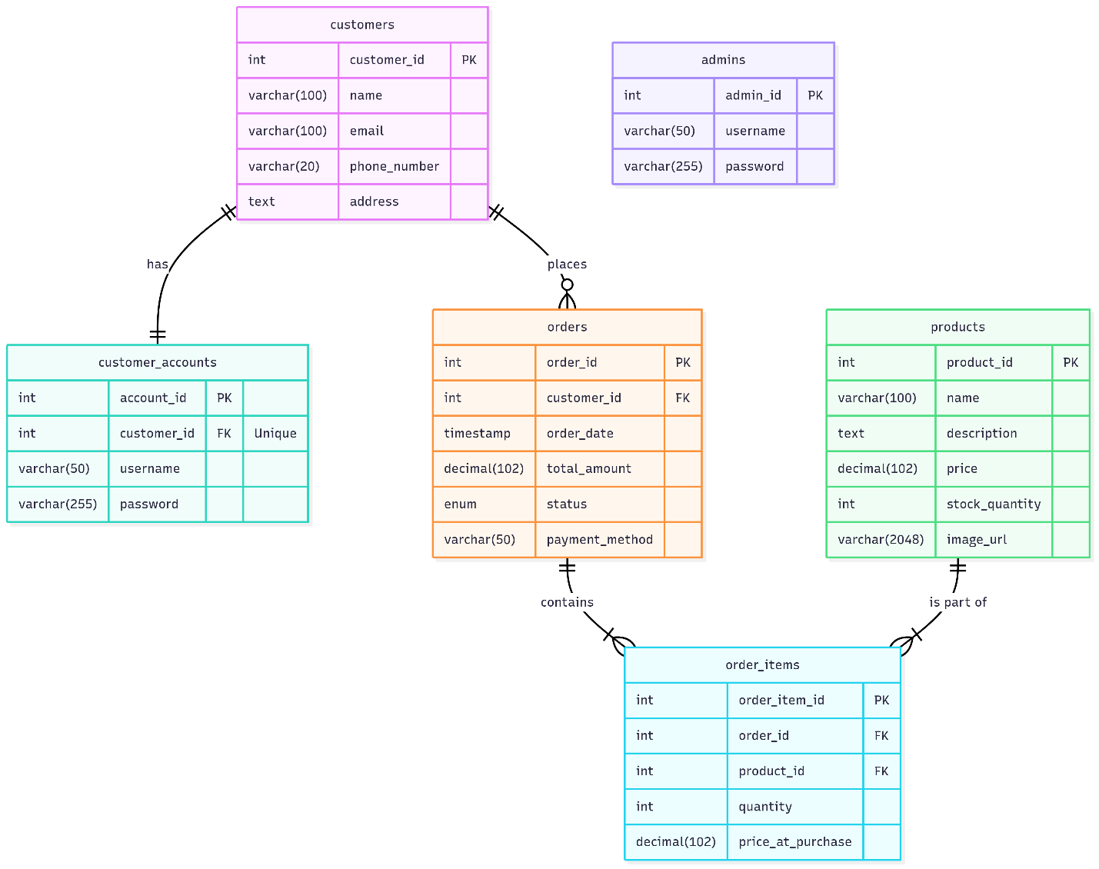

Database Schema and Tables
The database schema consists of six interconnected tables designed to logically store all the application's data.

admins
- Stores login credentials for administrative users.
- admin_id: INT, Primary Key, AUTO_INCREMENT
- username: VARCHAR(50), NOT NULL, UNIQUE
- password: VARCHAR(255), NOT NULL

customers
- Stores the personal profile information for each customer.
- customer_id: INT, Primary Key, AUTO_INCREMENT
- name: VARCHAR(100), NOT NULL
- email: VARCHAR(100), NOT NULL, UNIQUE
- phone_number: VARCHAR(20), NULL
- address: TEXT, NULL

customer_accounts
- Manages login credentials for customers, linking a profile to an account.
- account_id: INT, Primary Key, AUTO_INCREMENT
- customer_id: INT, NOT NULL, Foreign Key to customers(customer_id), UNIQUE
- username: VARCHAR(50), NOT NULL, UNIQUE
- password: VARCHAR(255), NOT NULL

products
- The master inventory table, containing all information for products sold in the store.
- product_id: INT, Primary Key, AUTO_INCREMENT
- name: VARCHAR(100), NOT NULL
- description: TEXT, NULL
- price: DECIMAL(10, 2), NOT NULL
- stock_quantity: INT, NOT NULL, DEFAULT 0
- image_url: VARCHAR(2048), NULL

orders
- Contains a header-level record for each sale transaction.
- order_id: INT, Primary Key, AUTO_INCREMENT
- customer_id: INT, NOT NULL, Foreign Key to customers(customer_id)
- order_date: TIMESTAMP, NOT NULL, DEFAULT CURRENT_TIMESTAMP
- total_amount: DECIMAL(10, 2), NOT NULL
- status: ENUM('Pending', 'Completed', 'Cancelled'), NOT NULL, DEFAULT 'Pending'
- payment_method: VARCHAR(50), NULL

order_items
- A junction table linking products to specific orders.
- order_item_id: INT, Primary Key, AUTO_INCREMENT
- order_id: INT, NOT NULL, Foreign Key to orders(order_id)
- product_id: INT, NOT NULL, Foreign Key to products(product_id)
- quantity: INT, NOT NULL
- price_at_purchase: DECIMAL(10, 2), NOT NULL

SQL Code
The following SQL script (mydb.sql) is used to create the database schema and insert sample data.
DROP DATABASE IF EXISTS `mydb`;
CREATE DATABASE `mydb`;
USE `mydb`;
CREATE TABLE `admins` (
`admin_id` INT NOT NULL AUTO_INCREMENT,
`username` VARCHAR(50) NOT NULL UNIQUE,
`password` VARCHAR(255) NOT NULL, -- In a real application, this should be a hash.
PRIMARY KEY (`admin_id`)
) ENGINE=InnoDB;
CREATE TABLE `customers` (
`customer_id` INT NOT NULL AUTO_INCREMENT,
`name` VARCHAR(100) NOT NULL,
`email` VARCHAR(100) NOT NULL UNIQUE,
`phone_number` VARCHAR(20) NULL,
`address` TEXT NULL,
PRIMARY KEY (`customer_id`)
) ENGINE=InnoDB;
CREATE TABLE `customer_accounts` (
`account_id` INT NOT NULL AUTO_INCREMENT,
`customer_id` INT NOT NULL UNIQUE,
`username` VARCHAR(50) NOT NULL UNIQUE,
`password` VARCHAR(255) NOT NULL,
PRIMARY KEY (`account_id`),
CONSTRAINT `fk_customer_accounts_customers`
FOREIGN KEY (`customer_id`)
REFERENCES `customers` (`customer_id`)
ON DELETE CASCADE
) ENGINE=InnoDB;
CREATE TABLE `products` (
`product_id` INT NOT NULL AUTO_INCREMENT,
`name` VARCHAR(100) NOT NULL,
`description` TEXT NULL,
`price` DECIMAL(10, 2) NOT NULL,
`stock_quantity` INT NOT NULL DEFAULT 0,
`image_url` VARCHAR(2048) NULL,
PRIMARY KEY (`product_id`),
CONSTRAINT `chk_product_price` CHECK (`price` >= 0),
CONSTRAINT `chk_product_stock` CHECK (`stock_quantity` >= 0)
) ENGINE=InnoDB;
CREATE TABLE `orders` (
`order_id` INT NOT NULL AUTO_INCREMENT,
`customer_id` INT NOT NULL,
`order_date` TIMESTAMP NOT NULL DEFAULT CURRENT_TIMESTAMP,
`total_amount` DECIMAL(10, 2) NOT NULL,
`status` ENUM('Pending', 'Completed', 'Cancelled') NOT NULL DEFAULT 'Pending',
`payment_method` VARCHAR(50) NULL,
PRIMARY KEY (`order_id`),
CONSTRAINT `fk_orders_customers`
FOREIGN KEY (`customer_id`)
REFERENCES `customers` (`customer_id`)
ON DELETE RESTRICT
) ENGINE=InnoDB;
CREATE TABLE `order_items` (
`order_item_id` INT NOT NULL AUTO_INCREMENT,
`order_id` INT NOT NULL,
`product_id` INT NOT NULL,
`quantity` INT NOT NULL,
`price_at_purchase` DECIMAL(10, 2) NOT NULL,
PRIMARY KEY (`order_item_id`),
CONSTRAINT `fk_order_items_orders`
FOREIGN KEY (`order_id`)
REFERENCES `orders` (`order_id`)
ON DELETE CASCADE,
CONSTRAINT `fk_order_items_products`
FOREIGN KEY (`product_id`)
REFERENCES `products` (`product_id`)
ON DELETE RESTRICT,
CONSTRAINT `chk_order_item_quantity` CHECK (`quantity` > 0)
) ENGINE=InnoDB;
INSERT INTO `admins` (`username`, `password`) VALUES ('admin', 'admin123');
INSERT INTO `products` (`name`, `description`, `price`, `stock_quantity`, `image_url`) VALUES
('Laptop Pro 15', 'A powerful laptop for professionals with a 15-inch screen and 16GB RAM.', 1299.99, 50, 'https://encrypted-tbn0.gstatic.com/images?q=tbn:ANd9GcTDwOC6_XLG0gr4PCKqb1CzYd1SzD6yb39CkA&s'),
('Wireless Mouse', 'Ergonomic wireless mouse with a long-lasting battery.', 25.50, 200, 'https://img.pikbest.com/backgrounds/20241129/wireless-gaming-mouse-for-pc-transparent-background-image_11145605.jpg!sw800'),
('Mechanical Keyboard', 'RGB backlit mechanical keyboard with tactile switches.', 89.99, 120, 'https://encrypted-tbn0.gstatic.com/images?q=tbn:ANd9GcS0-CcCafy-i2xenaniSP3VExk_BRwCSnEXBA&s'),
('4K Monitor 27"', 'A 27-inch 4K UHD monitor with vibrant colors and crisp details.', 349.00, 75, 'https://encrypted-tbn0.gstatic.com/images?q=tbn:ANd9GcT14DQNyNLKz8MU2uSJ8RluTD-NF0xq-Nmkkg&s'),
('USB-C Hub', 'A 7-in-1 USB-C hub with HDMI, USB 3.0, and SD card reader.', 39.99, 150, 'https://plugable.com/cdn/shop/files/main_ori_0a84a6f9-0f78-48ba-9222-977955e1f3d4.jpg?v=1718235273');
INSERT INTO `customers` (`name`, `email`, `phone_number`, `address`) VALUES
('John Doe', 'john.doe@example.com', '123-456-7890', '123 Main St, Anytown, USA'),
('Jane Smith', 'jane.smith@example.com', '987-654-3210', '456 Oak Ave, Somecity, USA');
INSERT INTO `customer_accounts` (`customer_id`, `username`, `password`) VALUES
(1, 'johndoe', 'password123'),
(2, 'janesmith', '123');
INSERT INTO `orders` (`customer_id`, `total_amount`, `status`, `payment_method`) VALUES
(1, 1325.49, 'Completed', 'Cash On Delivery');
INSERT INTO `order_items` (`order_id`, `product_id`, `quantity`, `price_at_purchase`) VALUES
(1, 1, 1, 1299.99),
(1, 2, 1, 25.50);

Business Rules and Data Integrity
To ensure the reliability and consistency of the system, several business rules have been implemented at both the application and database levels.

Category 1: Data Integrity & Format Rules
    - Valid Email, Name, and Phone Format: The application enforces standard formats for customer data. Emails must follow a user@domain.com pattern, names can only contain letters and spaces, and phone numbers must be numeric (with an optional leading +). This is implemented in StoreManagementApp.java using regular expressions (EMAIL_PATTERN, NAME_PATTERN, PHONE_PATTERN).
    - Uniqueness of Identifiers: To prevent duplicate records, admin usernames, customer emails, and customer account usernames must all be unique. This is enforced by UNIQUE constraints in the database schema (mydb.sql) and proactively checked in the application during registration.
    - Non-Negative Financials and Stock: Product prices and stock quantities cannot be negative. This rule is enforced by validation checks in the validateProductFields() method in the Java application and through CHECK constraints in the database.
    - Mandatory Fields: Key information such as usernames, passwords, and product details (name, price, stock) cannot be empty. This is enforced by NOT NULL constraints in the database and by checks for empty fields in the application's validation logic.

Category 2: Relational & Structural Rules
    - Customer ↔ Order Relationship: A single customer can place multiple orders, but each order belongs to only one customer (a one-to-many relationship). This is enforced via a foreign key in the orders table. The ON DELETE RESTRICT clause prevents the deletion of a customer who has existing orders, preserving historical data.
    - Order ↔ Product Relationship: An order can contain multiple products, and a product can appear in multiple orders (a many-to-many relationship). This is implemented using the order_items junction table.
    - Customer ↔ Customer Account Relationship: Each customer can have only one login account (a one-to-one relationship). This is enforced by making the customer_id in the customer_accounts table both a foreign key and a UNIQUE field. The ON DELETE CASCADE rule ensures that if a customer profile is deleted, their login account is also removed automatically.

Category 3: Process & Transactional Rules
    - Atomic Checkout Transaction: The entire checkout process—creating an order and updating stock—must succeed or fail as a single unit. This is achieved in the createOrder method of DatabaseManager.java by using a transaction block (setAutoCommit(false), commit(), rollback()) to ensure that all database operations are completed successfully or none at all.
    - Stock Availability Check: A customer cannot order more items than are available in stock. This is checked both in the application before checkout and guaranteed at the database level during the createOrder transaction, where the UPDATE statement includes a WHERE stock_quantity >= ? clause.
    - Historical Price Integrity: The price of an item in an order is permanently recorded at the time of purchase. This is accomplished by storing the price in the price_at_purchase column of the order_items table, ensuring that future price changes do not affect historical records.

System Modules / Features
The system is composed of several integrated modules designed to address the key needs of administrators and customers.

Admin Login
Provides secure access for administrators via a dedicated login screen. Authentication is handled by verifying credentials against the admins table in the database. Upon success, the user is redirected to the admin dashboard.

Product Management (Add / Update / Delete)
Administrators can perform full CRUD (Create, Read, Update, Delete) operations on the product catalog. Product details like name, price, stock, description, and image URL can be managed through a user-friendly interface with a table view and input forms.

Inventory Tracking
The system automatically deducts the quantity of purchased items from the total stock upon a successful sale. The admin dashboard provides a real-time view of stock levels, and the system prevents the sale of out-of-stock items.

Sales and Billing
This module manages the end-to-end sales process. It includes shopping cart management (add, update quantity, remove items), a checkout workflow with a simulated "Cash on Delivery" payment option, and automatic generation of a PDF receipt using the iTextPDF library.

Customer Management
Admins can view a list of all registered customers and their details. The current implementation allows admins to add new customers and delete existing customers through the management panel. Each customer account is linked to their profile and order history.

Screenshots

Dashboard:
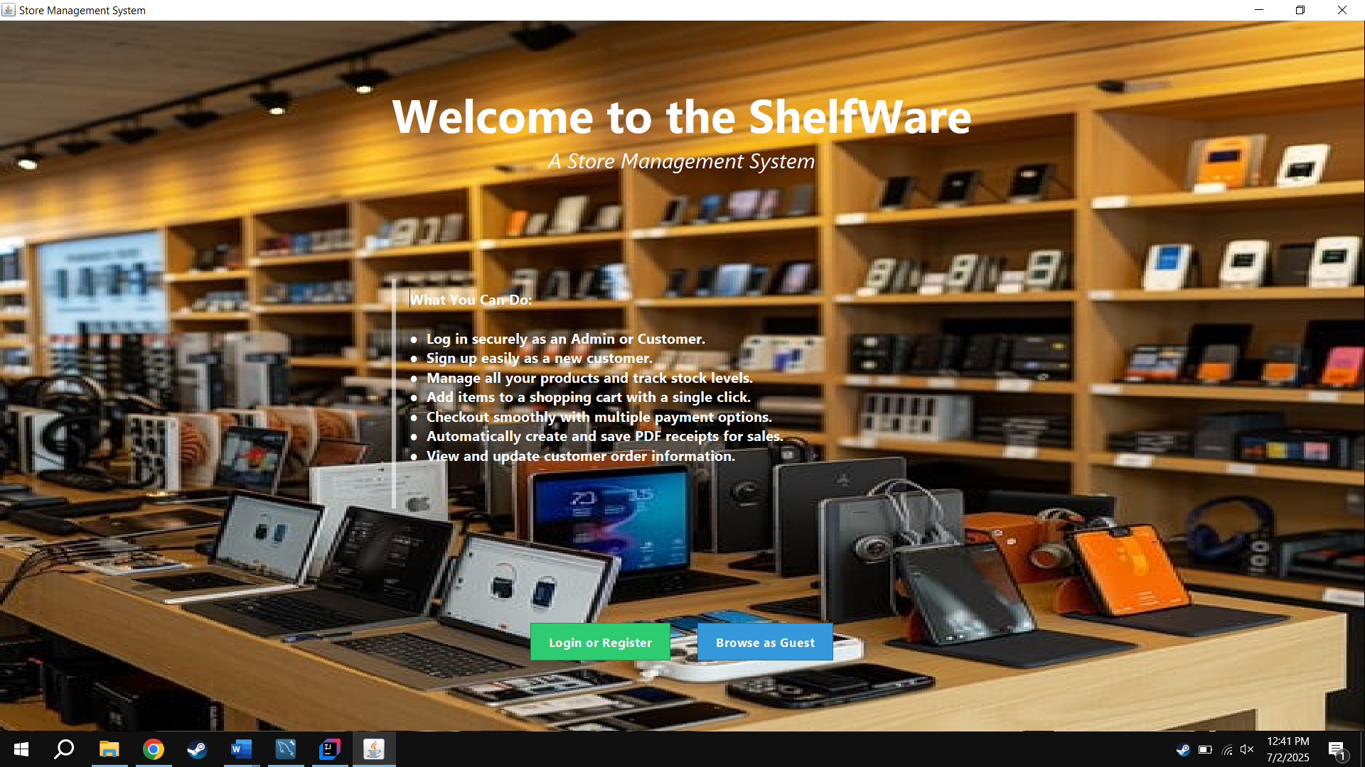

Login Options
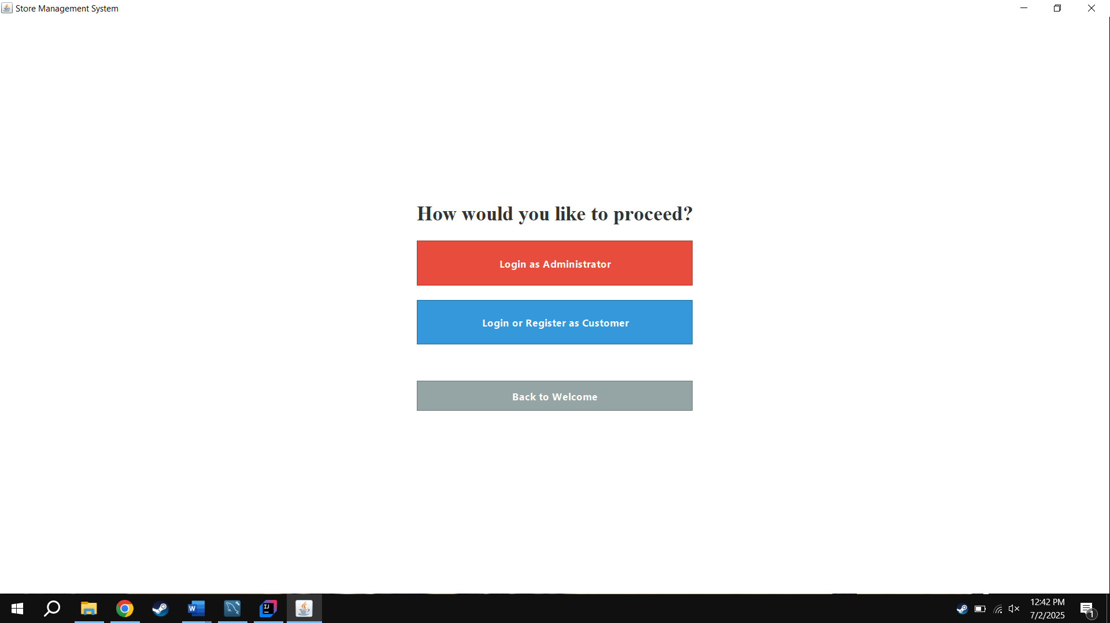

Admin Login
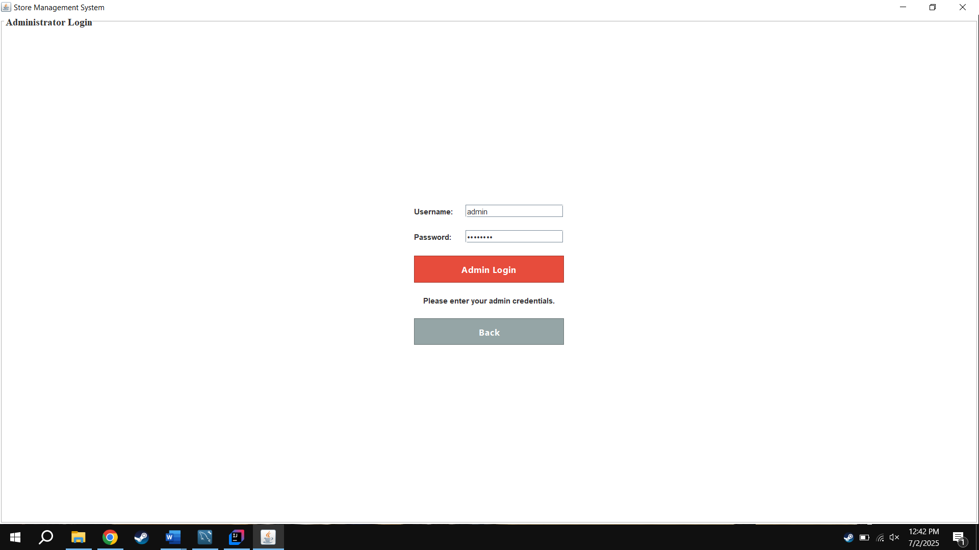

Product Management
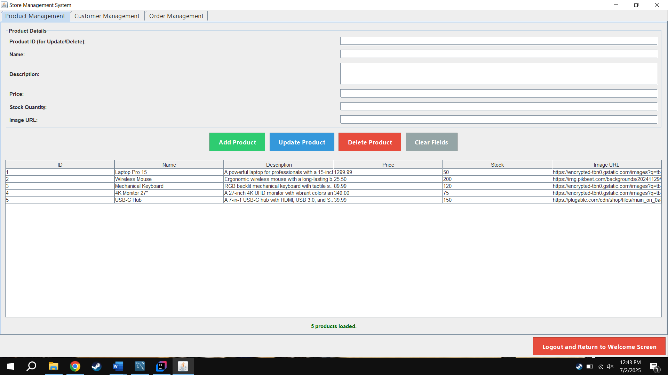

Customer Management
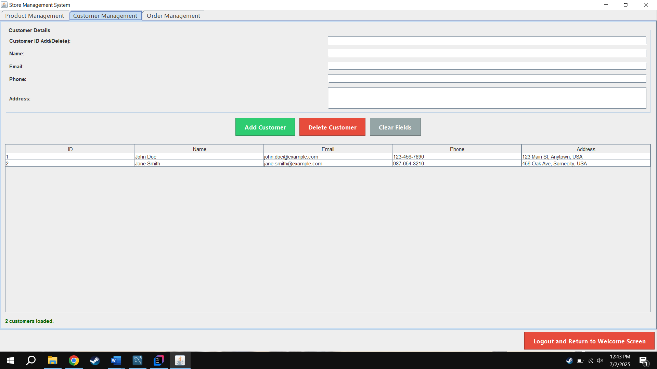

Order Management
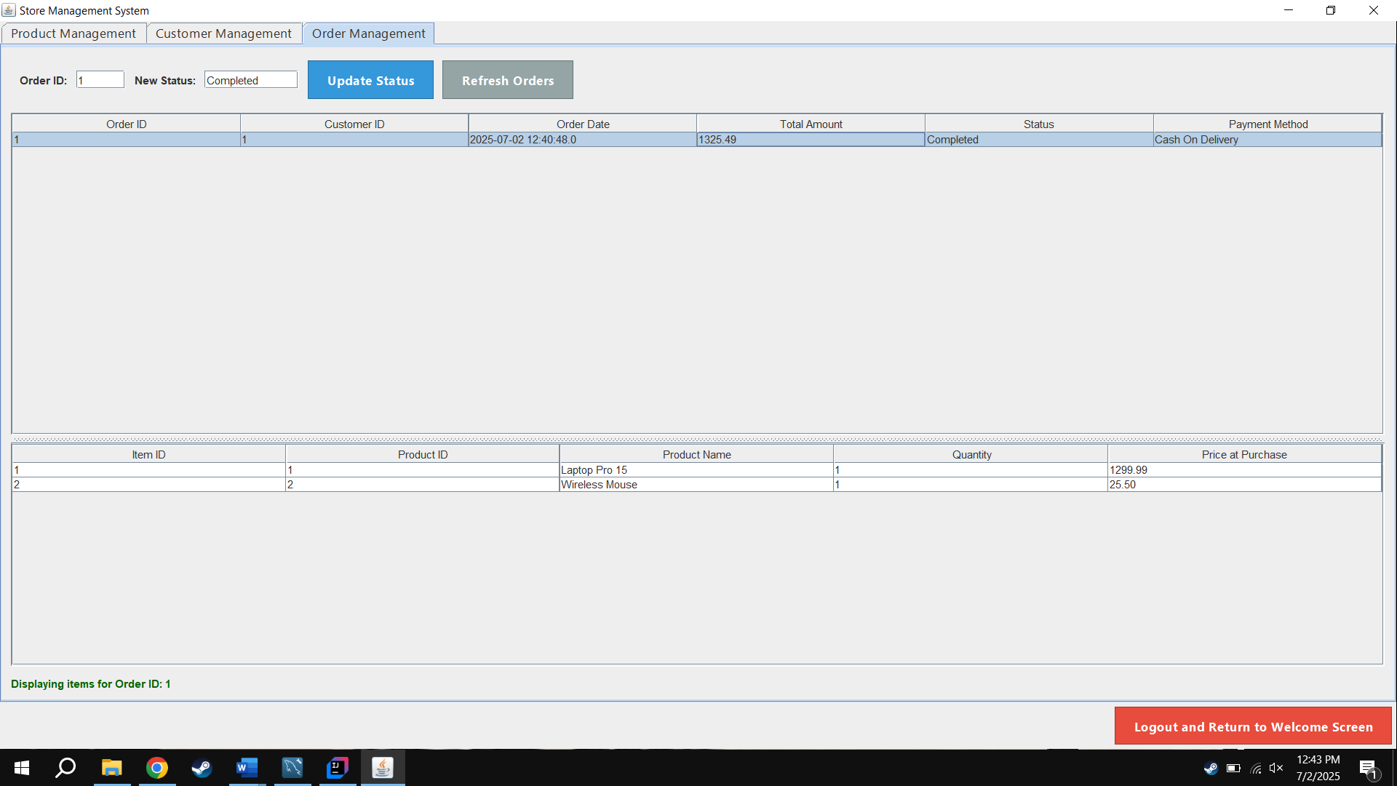

Customer Login & Registration Page
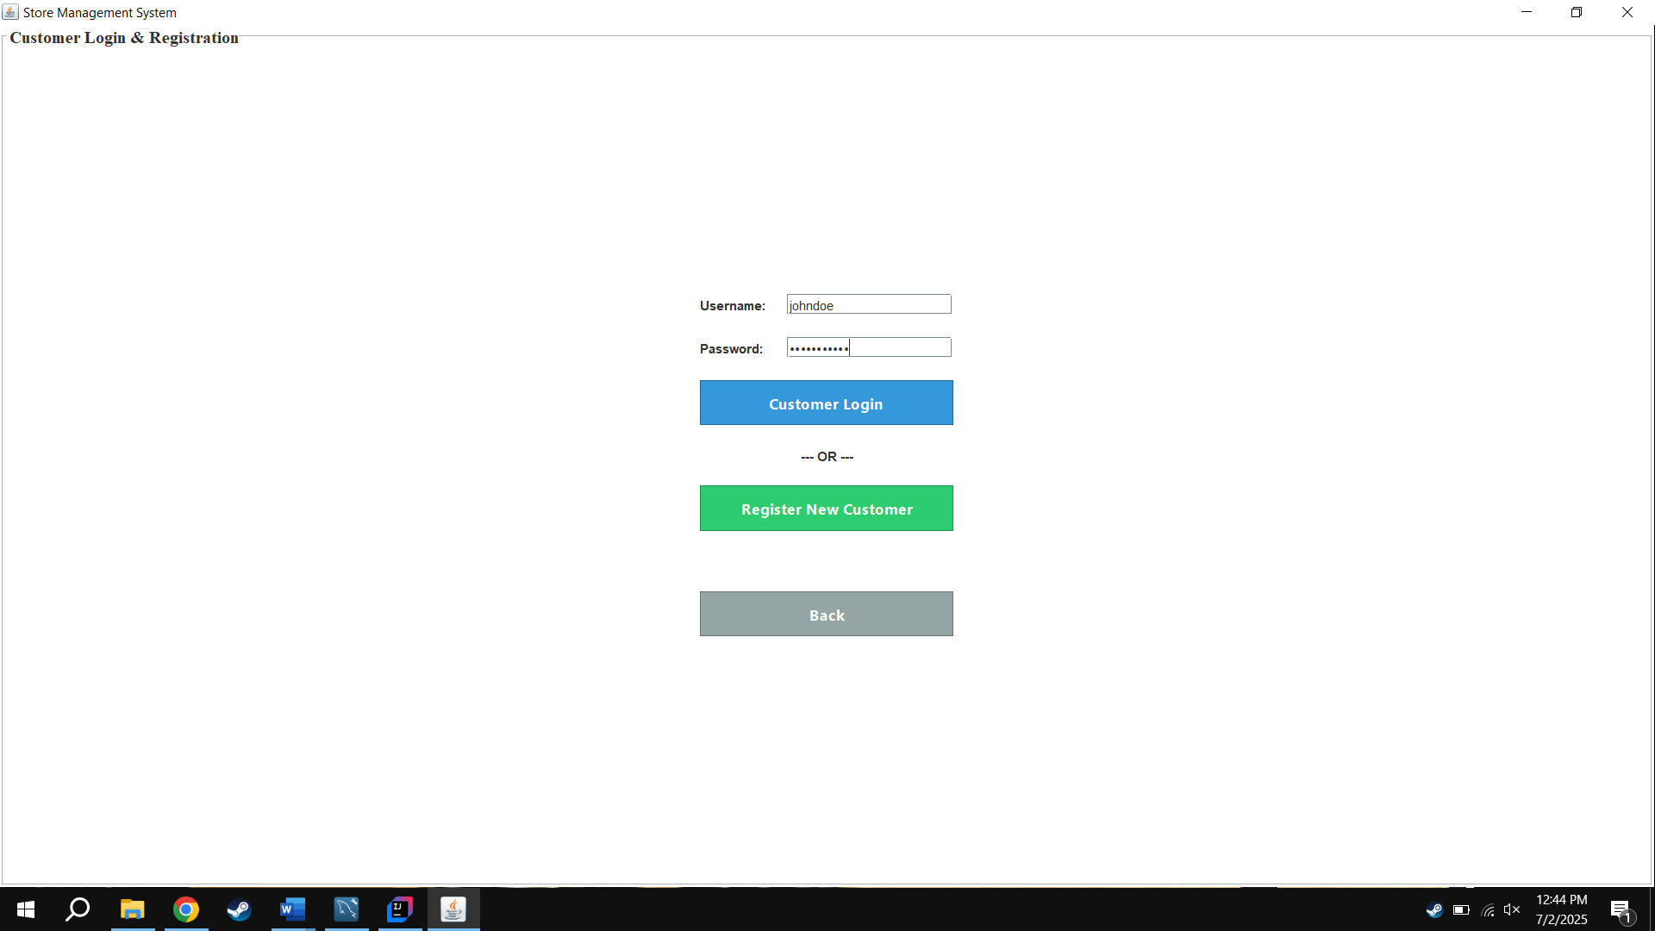

Registering New Customer
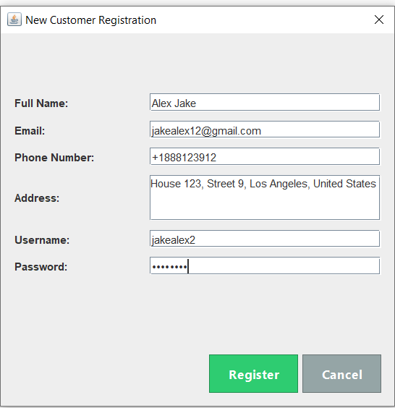

Customer Shopping Interface
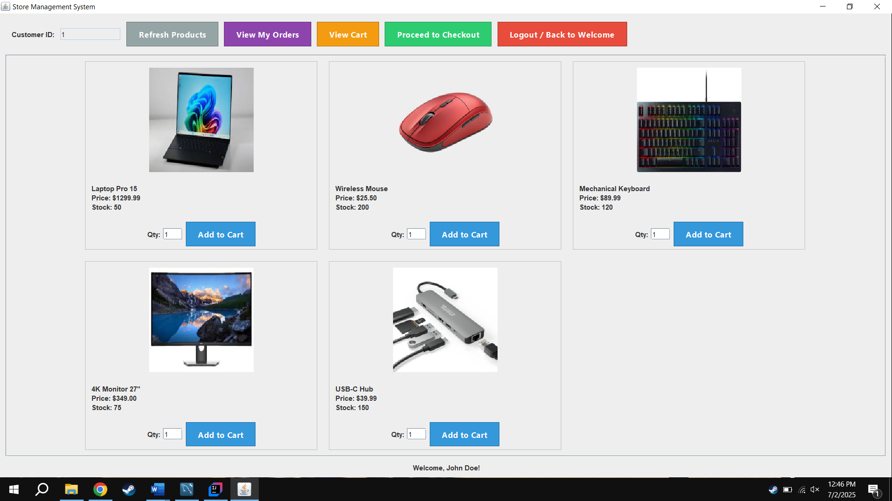

My Order History View
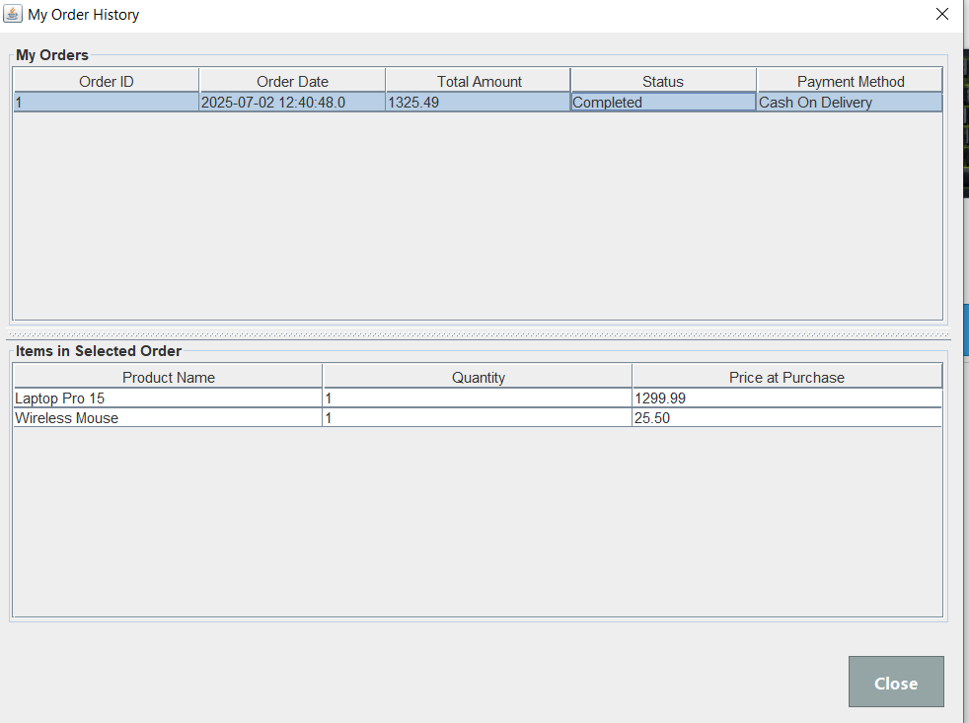

Shopping Cart View
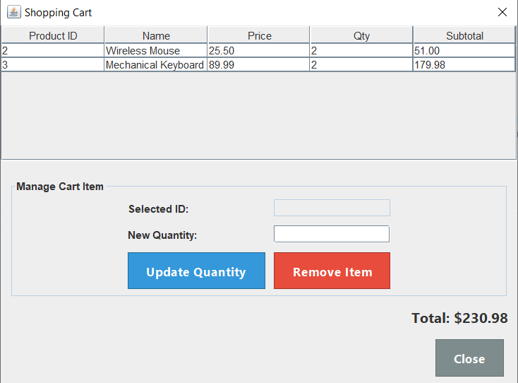

Checkout Payment Selection
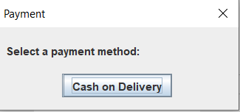

Checkout Success Confirmation
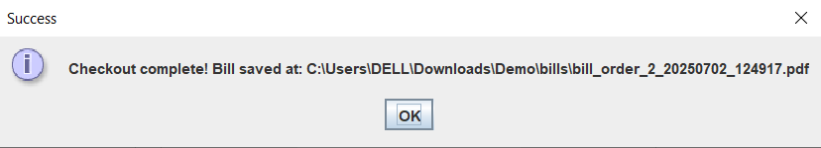

Generated PDF Bill
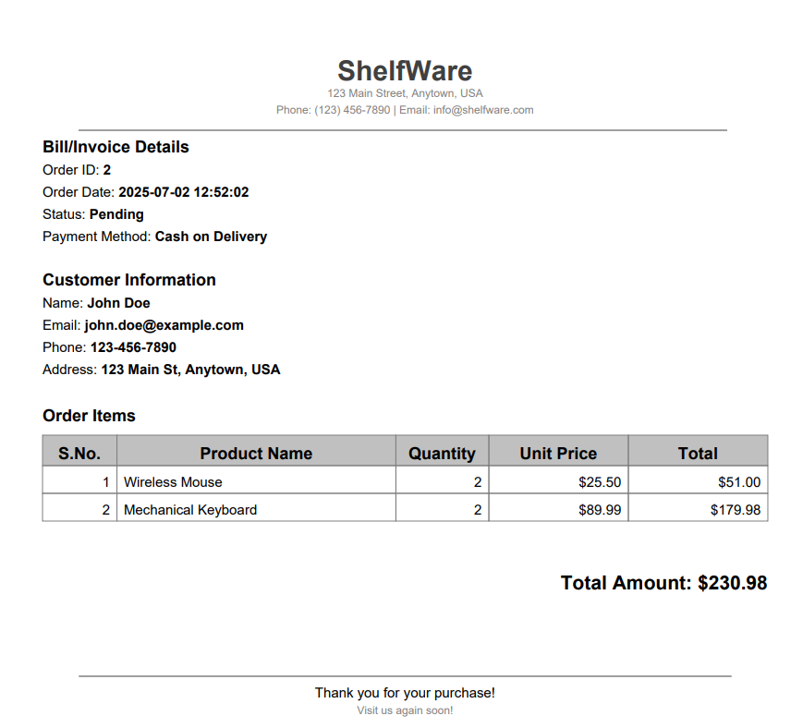

Working Explanation
This section provides a step-by-step explanation of the system's core workflows.

Application Startup and Navigation
    - Execution Start: The application launches from the main method in Main.java.
    - Database Connection: A DatabaseManager instance is created, establishing a single, persistent connection to MySQL. A window listener ensures the connection is closed gracefully on exit.
    - GUI Initialization: The StoreManagementApp frame is created, which initializes all UI panels and adds them to a CardLayout.
    - Navigation: User actions, like button clicks, trigger ActionListeners that use the CardLayout.show() method to switch between different panels (e.g., from the welcome screen to the login screen), creating a seamless single-window experience.

New Customer Registration Workflow
    - Initiation: The user clicks "Register New Customer" on the login screen to open the registration dialog.

    - Data Entry & Validation: The user fills in their details. Upon clicking "Register," the validateRegistrationFields() method checks for empty fields, validates data formats using regex, and makes a database call via dbManager.usernameExists() to ensure the username is not already taken.
    - Database Insertion: If validation passes, the system performs a two-step insertion: first, a new record is created in the customers table, and second, a linked record is created in the customer_accounts table using the newly generated customer_id.
    - Completion: A success message is shown, the dialog closes, and the application automatically logs the new user in.

Customer Shopping & Checkout Workflow
    - Product Display: The shop panel displays all products from the database. Images are loaded asynchronously using a SwingWorker to prevent the UI from freezing.
    - Adding to Cart: When a customer adds an item, Cart.java stores the product ID and quantity, preventing repeated database lookups for product details.
    - Checkout & Payment: The user proceeds to checkout. After confirming the cart is not empty, a dialog prompts for payment method selection ("Cash on Delivery").
    - Transactional Order Creation: The dbManager.createOrder() method handles the critical database operations within a transaction:
- It begins the transaction by setting autoCommit to false.
- It inserts a new record into the orders table.
- For each cart item, it inserts a record into order_items and decrements the product's stock in the products table.
- If all steps succeed, it calls commit(). If any step fails, it calls rollback() to undo all changes, ensuring data integrity.
    - PDF Bill Generation: After a successful transaction, PdfGenerator.generateBill() is called to create and save a PDF receipt to the bills/ directory.

Administrator Management Workflow
    - Authentication & Dashboard: After a successful login, the admin is taken to a JTabbedPane dashboard where all business data is loaded and displayed in tables.
    - Product Management: The admin can add, update, or delete products. Actions are validated and then executed via calls to the DatabaseManager.
    - Order Management: The admin can view all orders and, upon selecting one, see its detailed item list. They can also update the status of an order (e.g., from 'Pending' to 'Completed').

Challenges faced:
During the development of the Store Management System, several challenges were encountered both technical and non-technical. These obstacles provided valuable learning opportunities and helped us build not only a better product but also better project habits. Below are the key challenges we faced and how we overcame them:

Lack of Initial Planning and Workflow Understanding
At the start of the project, one of the biggest hurdles was not knowing how to begin. As beginners, we struggled with organizing the steps — whether we should start from the interface, the database, or the logic — which caused confusion and delays.
Resolution:
After some trial and error, we decided to:
- Create a simple project plan with a breakdown of tasks
- Follow the logical order of development: first database schema → then backend logic → finally the GUI
- Assign clear responsibilities (e.g., one person focused on GUI, another on database setup)
- Use checklists and regular meetings to track progress and maintain consistency
- This not only improved the workflow but also helped us learn how to manage software development in a structured way.

Difficulty in Initial Planning and Coordination
Coordination among group members was difficult due to scheduling conflicts. Some team members were day scholars with fixed bus timings, which made it challenging to hold consistent in-person meetings. As a result, progress was slower in the early stages.
Resolution:
To address this, we:
- Conducted a brief planning session to outline project stages
- Assigned specific roles and divided the workload logically (e.g., database setup, GUI development, logic implementation)
- Used group chats and shared checklists to stay updated remotely
- Committed to short but focused meetings during available time slots
- This structured approach helped us recover from the slow start and proceed with the development more efficiently.

Frontend and Backend Connectivity Issues
Initial issues occurred in connecting Java Swing with the MySQL database using JDBC.
Resolution:
- Verified correct driver installation
- Centralized all SQL code in DatabaseManager.java
- Implemented proper error handling and tested connections

Input Validation and Error Handling
The system initially accepted incorrect or empty data.
Resolution:
- Added robust validation using:
- Regex for email and name formats
- Numeric checks
- Required field enforcement
- Duplicate entry checks

Unattractive and Basic User Interface
The early UI was functional but looked plain and unengaging.
Resolution:
- Added background images and styled components
- Improved layout spacing and organization
- Used CardLayout for clean transitions

Freezing Interface During Image Load
GUI would lag when loading multiple product images.
Resolution:
- Used SwingWorker for background image loading, keeping the interface responsive.

Group Insight:
- Learned to work as a group
- Gained several skills like problem solving, coding, planning and communication
- Develop mutual respect by listening to each others ideas and sharing workload
- Learn to manage time efficiently under pressure and meet submittion deadlines
- Gained confidence in working as a team and completing a full fledge software project
- Divided responsibilities based on strengths
- Learned importance of planning and task breakdown before development

Limitations:
While the Store Management System successfully achieves its core objectives, there are certain limitations in its current version that could be improved in future iterations. These limitations primarily relate to security, real-time functionality, and scalability.

Plaintext Password Storage:
User passwords are stored and verified in plaintext, which poses a significant security risk. The system lacks encryption or hashing mechanisms, making it vulnerable to unauthorized access if the database is exposed.

Simulated Payment Methods Only:
The checkout process includes payment methods like Cash on Delivery but these are simulated for demonstration purposes. No real payment gateway (such as Stripe or PayPal API) is connected to process actual transactions.

No Real-Time Inventory Synchronization:
The system is designed as a single-user desktop application, which means it does not support real-time inventory updates across multiple machines or users. If more than one admin is using the system, conflicts could arise due to lack of synchronization.

No Notification or Alert System:
Currently, there are no built-in alerts or notifications for low stock, failed transactions, or inactive users, which limits proactive management.

Limited Reporting Capabilities:
The system lacks an advanced reporting module that could provide insights into sales trends, customer behavior, and inventory performance through visual dashboards or exportable reports.

No Role Customization or Access Control Levels:
The roles are limited to admin and customer with fixed permissions. There is no flexibility to define custom user roles or assign granular access levels to different parts of the system.

No Feedback or Review Mechanism:
Customers cannot leave feedback or reviews on products, which limits interaction and does not provide admins with insight into customer satisfaction or product performance.

Future enhancements:
Password Hashing: Implement a strong, one-way hashing algorithm like BCrypt for storing all user passwords securely.

Payment Gateway Integration:
Connect the checkout process to a real payment API like Stripe or PayPal to handle actual financial transactions.
  - Advanced Reporting:
Create a new dashboard tab for administrators to view analytics, such as sales charts over time, top-selling products, and most valuable customers.
  - Web-Based Interface:
Develop a parallel web application using a modern framework like Spring Boot (for the backend) and React/Angular (for the frontend) to make the system accessible from any device via a browser.
  - Mobile Application Version:
Developing a mobile version of the system using technologies like JavaFX for mobile or Flutter (if web-based) would make the platform more accessible to users on the go.

  - Role Customization and Access Control:
Future iterations can introduce custom user roles (e.g., cashier, inventory manager) with granular permissions, allowing better control over who can access which modules of the system.

Conclusion
The development of the Store Management System successfully integrated Java, MySQL, JDBC, and Java Swing to create a functional and user-friendly desktop application for small retail businesses. The project implements core features such as secure login, complete product and customer management, real-time inventory tracking, and automated PDF billing. The use of a multi-tiered architecture and transactional database operations ensures the system is modular, maintainable, and reliable.
This project significantly enhanced our skills in database design, object-oriented programming, GUI development, and system integration. We also developed crucial soft skills in time management, team collaboration, and problem-solving. While the system has limitations, such as plaintext passwords and simulated payments, it serves as a strong foundation for future enhancements. This experience has been both academically enriching and practically insightful, equipping us with the confidence and mindset needed for real-world software development.

References
- Oracle Java Documentation: https://docs.oracle.com/javase/8/docs/
- MySQL Reference Manual: https://dev.mysql.com/doc/
- Stack Overflow: https://stackoverflow.com/
- GeeksforGeeks: https://www.geeksforgeeks.org/
- iTextPDF Library Documentation: https://itextpdf.com/en/resources/documentation
- Java Swing Tutorials – Oracle: https://docs.oracle.com/javase/tutorial/uiswing/
- W3Schools – SQL Tutorials: https://www.w3schools.com/sql/

